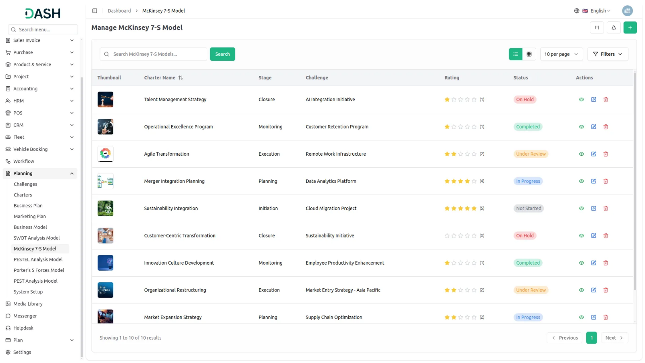

McKinsey 7-S Model Add-On offers a structured framework to assess and align critical elements of your organization including strategy, structure, systems, staff, skills, style, and shared values. Create and manage detailed models tailored to your business challenges, view them in dynamic formats like grid, kanban, or tree view, and gather feedback through built-in review and print features. This holistic tool empowers you to diagnose misalignments and drive continuous improvement with clarity and precision.
Dependency Notice: This Add-On depends on the Planning Add-On, so you must purchase and activate it first to access the McKinsey 7-S Model features.

Comprehensive Model Overview
Gain a holistic understanding of your organization's dynamics with the McKinsey 7-S Model Add-On. This feature-rich interface allows you to document and analyze all seven elements Structure, Strategy, Systems, Staff, Skills, Style, and Shared Values alongside descriptions, attachments, notes, and comments. Collaborate effectively by adding ratings and feedback, ensuring that every aspect of your organizational analysis is thorough and actionable.
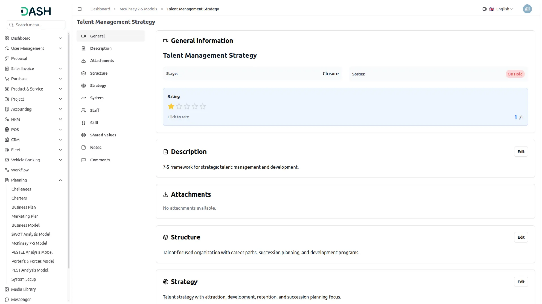

Strategic Overview At A Glance
Get a clear and organized view of all your McKinsey 7-S models in an intuitive grid layout. Instantly access key details like assigned users, total comments, attachments, and challenge deadlines with real-time countdowns. This snapshot-style overview makes it easy to monitor progress, collaborate efficiently, and keep your strategic initiatives aligned and on track.

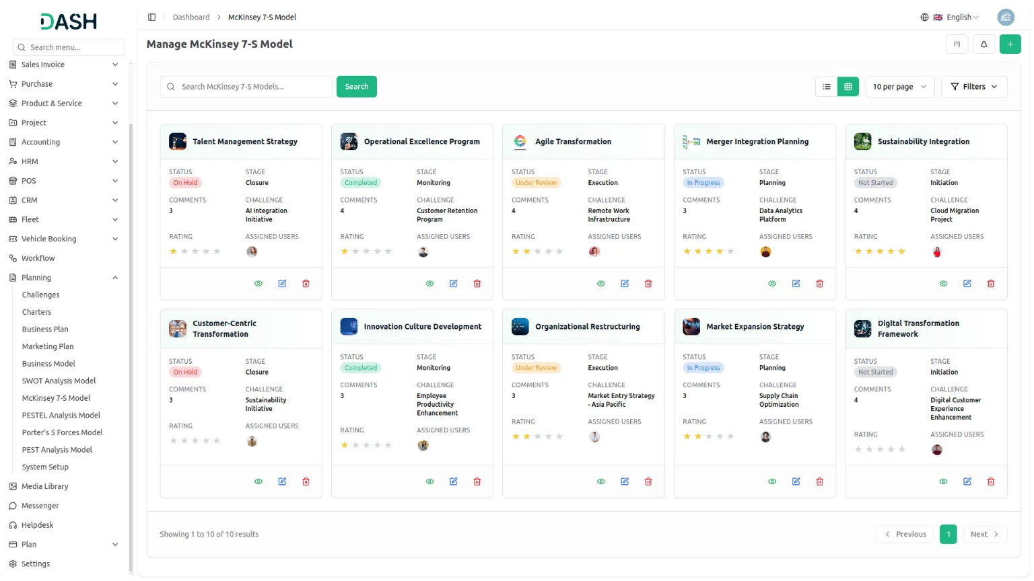
Organize & Align With Kanban
Visualize and manage your McKinsey 7-S models effortlessly using an interactive Kanban board. Organize models by stages, track progress with real-time counts, and quickly adjust strategies with drag-and-drop functionality. With the ability to view, print, and edit each model on the fly, That Empowers teams to keep structure and systems aligned with strategic goals all in one streamlined view.
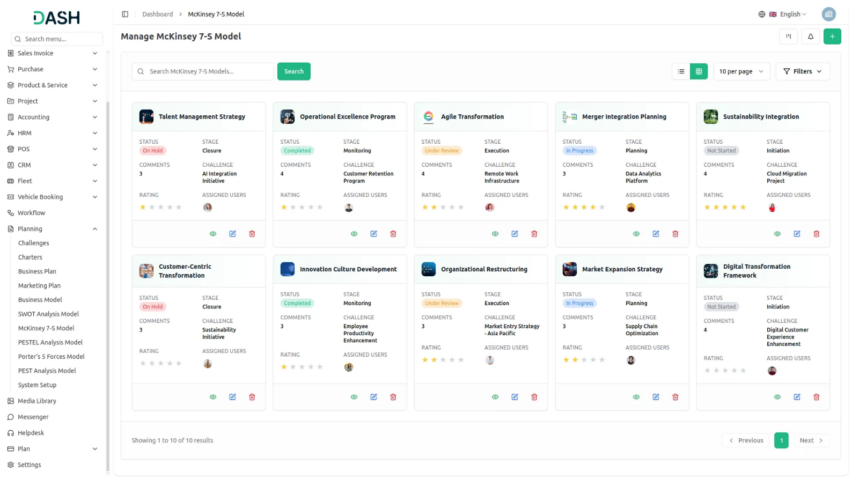

Challenge-Based 7-S Mapping
Visualize the McKinsey 7-S Model like never before using our dynamic tree view. Simply select a challenge from the dropdown, and instantly see a structured breakdown of models tied to that specific challenge. This hierarchical layout helps teams connect shared values and skills across the organization, fostering clarity, alignment, and focused strategic action.

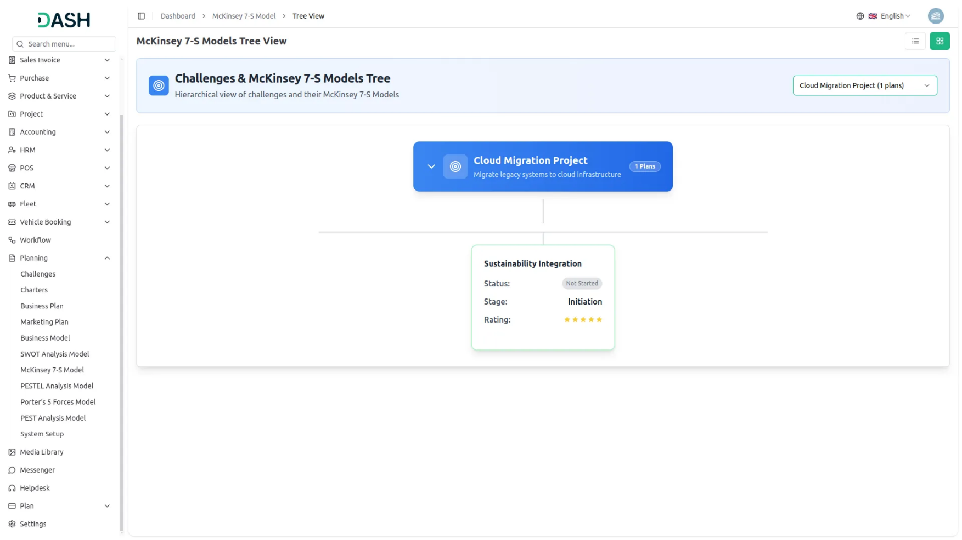
Introduction
The McKinsey 7-S Model is a strategic management software that helps organizations analyze and improve their internal alignment using seven key elements: Structure, Strategy, Systems, Staff, Skills, Shared Values, and Style. This Add-On allows users to create comprehensive organizational assessments linked to specific challenges, assign team members and roles, track progress through different stages, and manage multiple models through various viewing options including grid, kanban, and tree structure layouts.
Note: This Add-On is dependent on the Planning Add-On, so you need to purchase it first.

How to use the McKinsey 7-S Model Add-On?
Managing the McKinsey Model
- The default List View displays all McKinsey 7-S Models in a comprehensive table format with multiple management options. At the top of the page, you’ll find buttons for Create to add new models, plus three alternative viewing options for different management preferences.
- The main table presents detailed information with columns for Thumbnail providing visual identification, Charter Name of the model, Status fetched from System Setup showing current progress, Stage fetched from System Setup indicating model phase, Challenge fetched dynamically from Challenge Table showing associated business objectives, Rating for performance tracking, and Action column with management options.
- In the Action column, you have powerful options available: View to access complete model details and all strategic information, Edit to modify any aspect of the model including organizational assessments and team assignments, and Delete to remove models that are no longer relevant to your business strategy.

Creating the McKinsey 7-S Model
- To create a new McKinsey 7-S Model, click the “Create” button at the top of the page. Start by entering the Name for your strategic analysis model, which should clearly identify the scope or focus of your organizational assessment.
- Select the Challenge from the dropdown menu, which fetches data from the Challenges. Important note: if the current date is greater than the Challenge End Date, you will not be able to create a McKinsey 7-S Model, ensuring all models remain aligned with active or future business challenges.
- Upload a Thumbnail Image to provide visual identification for your model, and Upload Video content if you have supporting presentations or explanatory materials. Choose the appropriate Status from the dropdown menu, which fetches options from System Setup, and select the relevant Stage also fetched from System Setup to indicate the current phase of your analysis.
- Assign the Users involved in this strategic analysis by selecting users, and choose the appropriate Role from the Role dropdown to define team member responsibilities. Add a comprehensive Description that outlines the purpose and scope of your organizational assessment.
- Continue with the seven strategic elements by entering detailed information for Structure, explaining how your organization is organized and the formal relationships between different departments and levels. Document your Strategy by identifying your plan to achieve competitive advantage and business objectives.
- Add comprehensive details for the system, outlining the processes, procedures, and information systems that support your organization’s operations. Complete the staff assessment by documenting Staff, identifying the people in your organization and their capabilities.
- Enter information for Skills, explaining the capabilities and competencies your organization possesses. Document Shared Values by identifying the core beliefs, culture, and guiding principles that drive your organization’s behavior and decision-making.
- Include relevant Notes for additional observations, methodology details, or strategic insights, and attach supporting files through the Attachments field for research data, organizational charts, or reference materials. Once all fields are completed, click “Create” to create your McKinsey 7-S Model.

Viewing the Model
- To view a McKinsey 7-S Model, click the “View” button in the Action column of any model in the list. This opens the McKinsey 7-S Model Details page with a comprehensive view of all information organized in sections for easy navigation.
- The view page is structured with multiple sections starting with the General section which displays the model name, associated challenge, thumbnail image, uploaded video with playback controls, current status fetched from System Setup, stage information, assigned users from the Users Table, their designated roles from the Roles Table, and star rating system.
- The Description section shows the complete purpose and scope of the organizational assessment as entered during creation. This section provides detailed context about the model objectives and methodology. An “Edit” button is available below this section to add new description content.
- The Attachments section provides access to all supporting files including research data, organizational charts, reference materials, or any other documents uploaded during the model creation process. You can download or view these attachments directly from this section. Use the “Edit” button below to upload additional attachments.
- The Structure section displays all information about how your organization is organized and the formal relationships documented during the assessment. This section shows the complete organizational structure details identified during the strategic analysis process. Click the “Edit” button below to include additional structural information.
- The Strategy section shows your organization’s plan to achieve competitive advantage and business objectives.The System section displays the processes, procedures, and information systems that support your organization’s operations. The “Edit” button allows you to document additional strategic elements as they are developed.
- The Staff section shows information about the people in your organization and their capabilities. Review all staff-related documentation and human resource assessments. The “Edit” button enables you to document additional staff information as organizational changes occur.
- The Skill section displays the capabilities and competencies your organization possesses. This section provides detailed information about organizational skills and competencies identified during the assessment. Click the “Edit” button to include additional skill documentation.
- The Shared Values section contains the core beliefs, culture, and guiding principles that drive your organization’s behavior and decision-making. This section shows all values documentation from the analysis. Use the “Edit” button to add new shared values as organizational culture evolves.
- The Notes section contains additional observations, methodology details, strategic insights, or any supplementary information added during the model creation. This section provides context and additional commentary on the McKinsey 7-S analysis. Click the “Edit” button to include additional notes and observations.
- At the bottom is the Comment section where you can post comments easily. You can also attach files in the comments section if needed.

Kanban View
- The Kanban View organizes McKinsey 7-S Models into columns based on their current stage, providing a workflow-based visualization with drag and drop functionality. You can easily move models between different stages by dragging cards from one column to another.
- Each Kanban card shows essential information including the total number of assigned users working on the model.
- The drag and drop functionality allows you to update the stage of any McKinsey 7-S Model by simply moving it to the appropriate column. Action buttons on each card include View for detailed information, Edit for modifications, and Delete for removal. This view is ideal for tracking the progress of multiple models through different stages of completion.

Tree View
- To switch to Tree View, click the “Tree View” button at the top of the page. This view presents a hierarchical structure that displays challenges and their associated McKinsey 7-S Models in an expandable tree format, showing the parent-child relationships clearly.
- The Tree View includes expand/collapse functionality, indicated by the arrow icon next to each challenge name. Clicking the arrow allows you to expand the challenge to reveal its associated models or collapse it to show only the challenge title, making navigation more organized and focused.
- In the Tree view, each challenge appears as a blue header bar with the number of plans indicated. When expanded, it displays the associated models beneath it in card format, showing key details including the model name, status, stage, and rating displayed as stars.

